Press Release
Media Contact
Marius Strasdat
T +49 241 5689-6452
strasdat@fev.com

www.fev.com

FEV Leads the Way in Automated Driving

Aachen, Germany, September 2021 – Driver assistance systems such as automatic distance and lane-keeping functions are already increasing safety, driving comfort and energy efficiency in vehicles. However, from level 3 driving functions onwards, in which the autopilot takes over complete control of the vehicle, the increasing complexity increases the demands on the performance of the sensor technology, the control functions and the required computing capacity.

FEV has developed unique methodologies for the technical development of these systems, which the leading development service provider for vehicle and powertrain development as well as digital mobility is already using successfully in projects with vehicle manufacturers and suppliers. They are used to examine and validate vehicle behavior in a wide variety of driving situations and cover the areas of systems engineering, data management, and functional, system, and vehicle testing.
The scenario and model-based systems engineering (MBSE) concept developed by FEV brings many advantages in this context. On the one hand, its application helps to control system complexity, and on the other hand, the high, steadily increasing verification and validation efforts for automated driving functions can be controlled.

Scenarios define desired functions
MBSE uses scenarios that describe complex traffic situations for the architecture and design of systems for automated driving in a comprehensible way during the development of highly automated driving functions. Taking into account so-called use cases, they define the desired behavior of the function, taking into account all relevant interactions with the environment, the driver and other road users.
"By incorporating scenarios into our MBSE approach, we ensure validation of the developed driving functions. For example, precise test scopes for individual requirements can be assigned and combined into test scenarios for different test platforms," said Dr. Elmar Boerner, Senior Group Director for ADAS (advanced driver assistant systems) and AD (automated driving systems) development at FEV. "The scenario thereby describes temporal relationships between different scenes. Scenes, in turn, are snapshots of the environment, dynamic elements and all actors, as well as the observer's self-representation and relationships to each other."
Scenarios are linked via use cases with the customer benefits and the modeling of the system behavior including the associated requirements. Thus, they are the supporting link within requirements development and the basis for test case creation.

Real-time data acquisition
As part of the requirements creation within the MBSE approach, FEV's scenario is integrated as a central element in the development environment. The company's self-developed data acquisition chain is of central importance here. It collects measurement data from FEV's autonomous vehicles during test drives with the help of a networked logger and can already classify them into scenarios during the measurement drive. The collected data also allows scenarios to be analyzed directly during the validation phase and prepared for simulation in corresponding databases. The comparison with specified scenarios thus realizes a continuous development chain from system design to system test and back.

Time saving through automation
FEV's design differs from conventional systems for highly automated driving functions. The use case definition is extended by a scenario specification at each breakdown level in the context of customer requirements and linked to relevant scenarios. FEV uses its proprietary MBSE methodology for this purpose.
The clear and formal traceability between individual requirements and possible operating states thus results in high automation potential - for example, in database analyses and test case derivation. Test scopes are also unambiguous and the overall test scopes are optimized and reduced compared to an ODD (Operational Design Domain, i.e. the operational framework conditions for the system function) view at the overall function level.

In the further course, modeling is carried out using the information contained, for example, on the road, traffic infrastructure, time-limited modifications such as construction site signs, moving objects, environmental variables such as the weather, etc. The model can also be used to generate test cases for various simulation environments with the help of automation. On the one hand, component requirements can be defined - for example, for the performance of the sensors - and on the other hand, test cases for various simulation environments can be generated with the help of automation.

This reduces the verification and validation scopes to a great extent, since even more complex scenario spaces can be covered by clever modeling of scenarios with automatically generated test cases. Such scenario spaces are required, for example, for simulation in cloud environments and for model and software-in-the-loop tests with wide-ranging variations in the context of "corner case" simulations.

Thanks to this FEV methodology, automated driving functions from Level 3 upwards can be developed quickly and reliably.

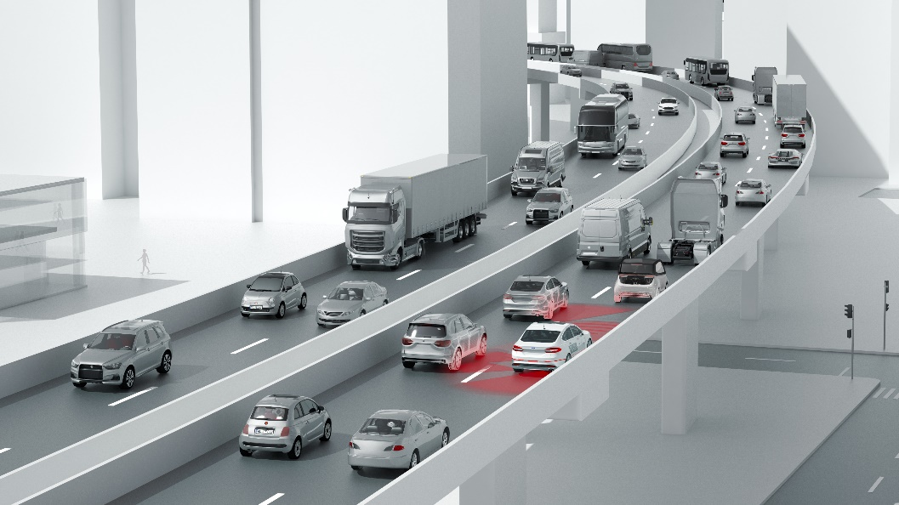
By applying the scenario- and model-based systems engineering concept (MBSE) developed by FEV, the system complexity of automated driving functions from level 3 upwards can be mastered. In addition, the necessary high, steadily increasing verification and validation efforts can be controlled.
Source: FEV Group
About FEV
FEV is a leading independent international service provider of vehicle and powertrain development for hardware and software. The range of competencies includes the development and testing of innovative solutions up to series production and all related consulting services. The range of services for vehicle development includes the design of body and chassis, including the fine tuning of overall vehicle attributes such as driving behavior and NVH. FEV also develops innovative lighting systems and solutions for automated driving and connectivity. The electrification activities of powertrains cover powerful battery systems, e-machines and inverters. Additionally, FEV develops highly efficient gasoline and diesel engines, transmissions, EDUs as well as fuel cell systems and facilitates their integration into vehicles suitable for homologation. Alternative fuels are a further area of development.

The service portfolio is completed by tailor-made test benches and measurement technology, as well as software solutions that allow efficient transfer of the essential development steps of the above-mentioned developments, from the road to the test bench or simulation.
The FEV Group currently employs 6,300 highly qualified specialists in customer-oriented development centers at more than 40 locations on five continents.

